Sommario

Intro 3

Context 3

Reference institutions with its institutional goals 3

Relevant assets and target audience (include raster images or/and panoramas) 5

The target audience with characteristics, motivations, capabilities and devices) - The visitors. 6

The location 6

The concept 6

Specific CH topic selected as case study. Where the idea comes from 6

Chosen cognitive focus among: 1.Attention-Distraction, 2.Language-Narrative, 3. Meaningfulness-Emotions-Empathy, 4. Authenticity perception, 5. Memory-Recall - 2nd step 9

Creation of the VE 10

Conceptual map 11

B. The museological approach - 3rd step 12

(c) experience design (from the users perspective) (include a diagram) 13

CREATING PROCESS: DESIGN CARDS 13

THE EXPERIENCE (CREATING PROCESS) 15

Goals 15

Requirements 15

Development 16

(a) The story (include an interactive narrative using Twine) 16

PERSONAE 17

SCENARIO 19

SCENARIO 21

(b) Description of the interaction between the project and the users (include Interaction Diagram) 21

Choose your guide 21

Share your Stories 21

3d print your pet! 23

Search for your pet! 23

(c) Development to reach the cognitive focus 24

.... 24

(c) Foreseen workflow (includes needed software, hardware, professionals) 24

.... 24

(d) Further development and maintenance issues 24

Team roles 24

Enrica Zani and Bigio 24

Alisia Zarbo 25

Bibliography 25

Project 25

In History section (vedere se riusciamo a richiamare le bibliografie dei modals) 26

In Art section 26

Complementary Material for the Discussion 26

3d object or scene (3D): Frida room’s 26

Trailer (video)--> NO 26

Audio (i.e. interviews of your potential users) --> NO 26

Project Work Design Brief

# Intro

**Wanted!** is a project that have been inspired by a corpus of *lost-pets-advertisements* photographs, collected over the years in various places. It is focused on the complex relationship between humans and their pets in an anti-speciesist [nota] view of interpersonal relationship and family's bounds.

The name **Wanted!** obviously comes from the strong visual relationship of these SOS-flyers with the *Old West* bandit bans.  
The website is conceived as a multi-dimensional cultural environment offering different paths to be explored such as a **current virtual exhibition with related interactive applications**, a growing **souvenir-book** built from users’ stories and some **data-visualization**.

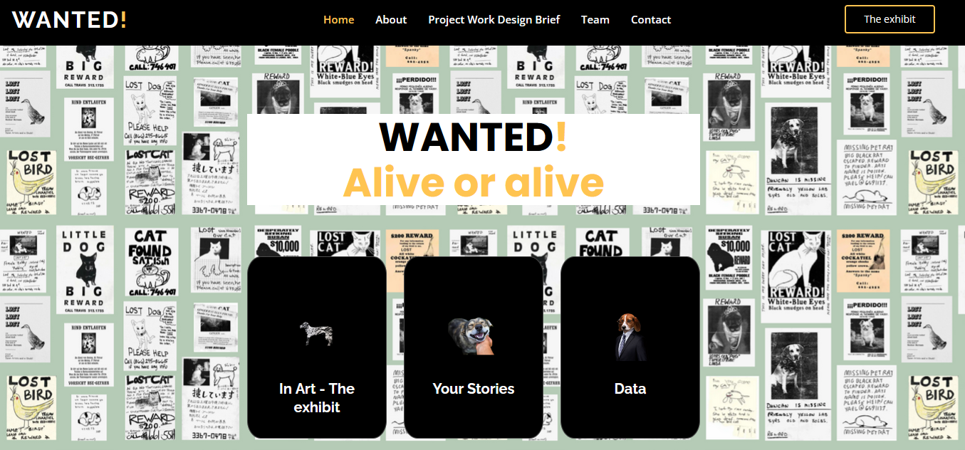

--

The fascination for the affective and memorial effect of these images prompted us to think about the creation of a virtual space that would allow the preservation of the memory of these beloved ones - most of them no longer found - through the telling and sharing of their stories, with the intent of arousing emotions such as memory, empathy, sympathy and socializing the pain of a loss or the joy of a happy ending.  
At the same time, the project would also like to become a support tool in the search for the animal in the early stages of its disappearance, through the possibility of directly publishing the loss announcements accompanied by geolocation data. Each user can have the option to upload and share their own story or simply link that of others.  
In addition to the suggestion of the user's emotional-cognitive aspect, the project also wants to provide an informative contribution, presenting some stories, works, performances of artists who have wanted to consecrate their emotional ties with their animal.

--

## Context

### Reference institutions with its institutional goals

When we started thinking about this project, as said inspired by a self-collected corpus of photographs, which a sample is in the [Preliminary data section](https://enri-ca.github.io/WANTED/index.html#preliminary_data), the first visual references we thought about had been **memorials** museums and installations such as the [Museo per la Memoria di Ustica](https://www.museomemoriaustica.it/il-museo/) - hosting a Boltanski work, artist specially devoted to memory and memorial issues - or the initially spontaneous [Sacrario partigiani in Piazza Nettuno a Bologna](https://www.storiaememoriadibologna.it/sacrario-partigiani-in-piazza-nettuno-a-bologna-892-opera) - to mention two Bolognese’s examples - or the Argentinian [Archivo Provincial de la Memoria/Ex D2](https://apm.gov.ar/apm/portada). All these institutions are devoted to preserve the public testimony of historical facts as well as to celebrate the intimate memory of missed beloved-ones.  
Although, we soon realized that, even if a strong memorial component was present in our inspirational material, we would also find the way to celebrate the **joyful** part of the relationship with the - hopefully momentaneously - lost pets.

For this part we explored some examples such as those mentioned by Simona Caraceni in her Mewselogy course slides (Hermitage cats army guards, [Le chat du Louvre](https://bigcomicbros.net/work/6195/), [Cat Museum Kotor](http://catsmuseum.org/) and Cats Museum Malaysia): even these references have not been satisfying for our intents, because these museums often celebrated single pets, or a one species of them (dogs, cats, etc.) while we were looking for an institution exploring the complex emotive human-pet relationship "species-independent".

We then realized the [In Art](https://enri-ca.github.io/WANTED/in_art.html) section, conceived as a virtual exhibition about this topic: the idea, involving famous visual artists, is to achieve the double goal of humanising the artist and making their emotive world closer to that of the user. We then choose some artists and their pets such as **Frida Kahlo and Granizo**, **Giosetta Fioroni and Petote, Pablo Picasso and Lump, Henry Matisse and Minouche, Salvador Dalì and Babou,** etc.

The overall context will be then a Virtual Exhibition about the artists-pets relationship sketched in the [In Art](https://enri-ca.github.io/WANTED/in_art.html) section: the VE collects different contents – books, paintings, photographs - belonging to different institutions for building different museological paths (static VE, 3d exploration, interactive applications, etc.)

The visitor will have also the possibility of loading and sharing their personal stories - [Your Stories](https://enri-ca.github.io/WANTED/index.html#portfolio) section - and possibly a tool able to help proactively people loosing their pets by visualizing geolocated shared data of missing pets - [Data](https://enri-ca.github.io/WANTED/PWBD.html) section.

possibly a physical museum hosting a temporary physical exhibition on humans and artist and their pets relationship, that offers also the possibility to the visitors of having an online introduction - [In History](https://enri-ca.github.io/WANTED/PWBD.html) section - a further online exploration

|  |  |
| --- | --- |
|  |  |
| Sacrario. Bologna 1945 o 1946. Il Sacrario dei caduti della Resistenza in Piazza del Nettuno a Bologna. Credits [Istituzione Bologna Musei](https://www.storiaememoriadibologna.it/crediti) | Virtual exhibition on artist-pet relationships |

**PUT "PACT FRAMEWORK".**

### CH Relevant assets (include raster images or/and panoramas)

We arrived to define that the most suitable context for our purposes was the Virtual Exhibition thanks to a recursive design process using the Design cards.

In fact, the cards have been a useful tool to explore the relevant assets and the hypothetical proper target audience for two the contexts: a physical museum and the virtual exhibition.

As a reference physical institution we took the …. And we used it until the STAGE 3 –

#### STAGE 1 – Define context

|  |
| --- |
| PHYSICAL REFERENCE INSTITUTION |
|  |

|  |
| --- |
| VIRTUAL MUSEUM |
|  |

The two institutions, as shown in the table below, have in common just the “exhibit” asset and differ basically in the other:

|  |  |
| --- | --- |
| **Physical Museum** | **VE** |
| Retail  location  fame  exibhit* | Guides  digital resource  outreacht activities  exibhit* |

### The target audience with characteristics, motivations, capabilities and devices)

From the same previous step of the Ideation Cars, we can outline that the two institutions have more point of contacts in the target audience than in the assets: in fact, they share at least **art and animal passionate** as well as the part of **users enjoying collections online**. All of these audiences are quite **familiar with technological devices** that they use for several daily tasks (find an address, search for a professional, sending and receiving email and instant messaging, etc.)

A deeper analysis on the target audience on the Personae methodology is available in the Development section.

|  |  |
| --- | --- |
| Physical Museum | VE |
| digital visitors  art passionate*  casual tourist  animal passionate* | sofa lovers  art scholars*  skids  passionate with pets* |

### The location

As already mentioned, our VE and applications are thought to be autonomously used online, and according to ??? (Beltramini and Gaiani, 2012: 60). and thus we can use to define it these two categories:

4.Virtual with real: in this category the researchers have identified a type of virtual museum that they define as a digital space built with the use of technology. This virtual space can shape a real space or an ideal space shaped for virtual exhibition. What identifies the virtual museum is that the objects shown are real objects that have been digitalised for display in a virtual space to be better studied or browsed.

5.Virtual with virtual: this last category covers museums with digital spaces that do not exist in reality, and where the objects are also born in digital space (they do not exist in real world), and are created only for the museum. That is to say a completely virtual museum, according to this classification.

## The concept

### Specific CH topic selected as case study. Where the idea comes from

As already introduced, we started from a *lost-pets-advertisements* photographs corpus collected between 2014 and 2020 in different places around the world and we put part of this collection in the [Preliminary data section](https://enri-ca.github.io/WANTED/index.html#preliminary_data). We also realized specific pages for three sample flyers (Nobu, Gringo and Luli): in those pages we organized the data, spread in natural language in the free-text, in a table with common fields such as the pet name, the type of pet, some keyword.

The “preliminary data” have been then used as an observation set through which extracting information to define our Personae because we immediately noticed recursive patterns in both - the visual and the textual - composition of these leaflets that could be helpful to extract some information about the producers.

#### WORD ANALYSIS on the preliminary data

We have been particularly impressed by the sentimental value that most of these flyers express about the affective tie between the lost pet and their humans.

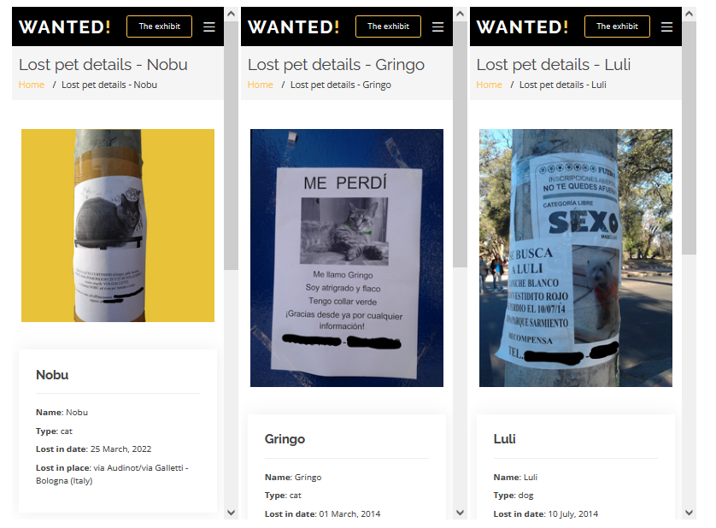

Often the expressive power of the words used to describe the physical and behavioural aspect of the pet was among the most interesting parts; ~~actually, it push us to think about it in a wider way, including all the potential fields in which it could be interesting to study in deep this affective value.~~

In the flyer for Nobu <LINK>, "GATTO CERTOSINO (Grigio, pelo lucente)", for example, we highlighted the words **"timido"** (shy) and **"tonto"** (dumb) as a clear exemplification of the humanising of animals, more specifically, the attribution of human's traits, emotions, or intentions to non-human entities.

Gringo is talking in first person “**Me perdì” (I got lost)**; in addition, its announcement shows another recursive pattern – common to others as i.e. Luli – such as the manual intervention of the caregiver to make the visual communication more expressive, putting manually some peculiar colour – “green collar” or “vestido rojo” to a poor A4 b/w laser-printed copy.

These repeated features revealed a strong communicative and emotive engagement from “the human” creating the flyer, looking for its lost pets but also trying to share all the emotive pain of this missing.

Many theories have been published about this practice in human's history, since it is present (in different shapes) from the beginning of it. As we said, anthromopomorphization changes its shapes with the history and its tendencies;

#### SOCIAL NETWORKS examples

We decided to also explore the social media situation, in order to have an overview about the impact of animals in general and pet in particular in the era of digitalization and virtual socialisation.

We found that nowadays, in the era of technology and social media, animals have been humanized also becoming protagonists of social posts and even owners of social media pages, with millions of followers.

Some examples of profiles are provided below; we then we summarise some of these analysis in the [On Social media](https://enri-ca.github.io/WANTED/index.html#social_data) data section. (mettre igtame)?

This tendence encouraged us to search in deep about it, analysing data on social media and reading other statistical research about the importance of the animal in the era of digitalization and virtual socialisation.

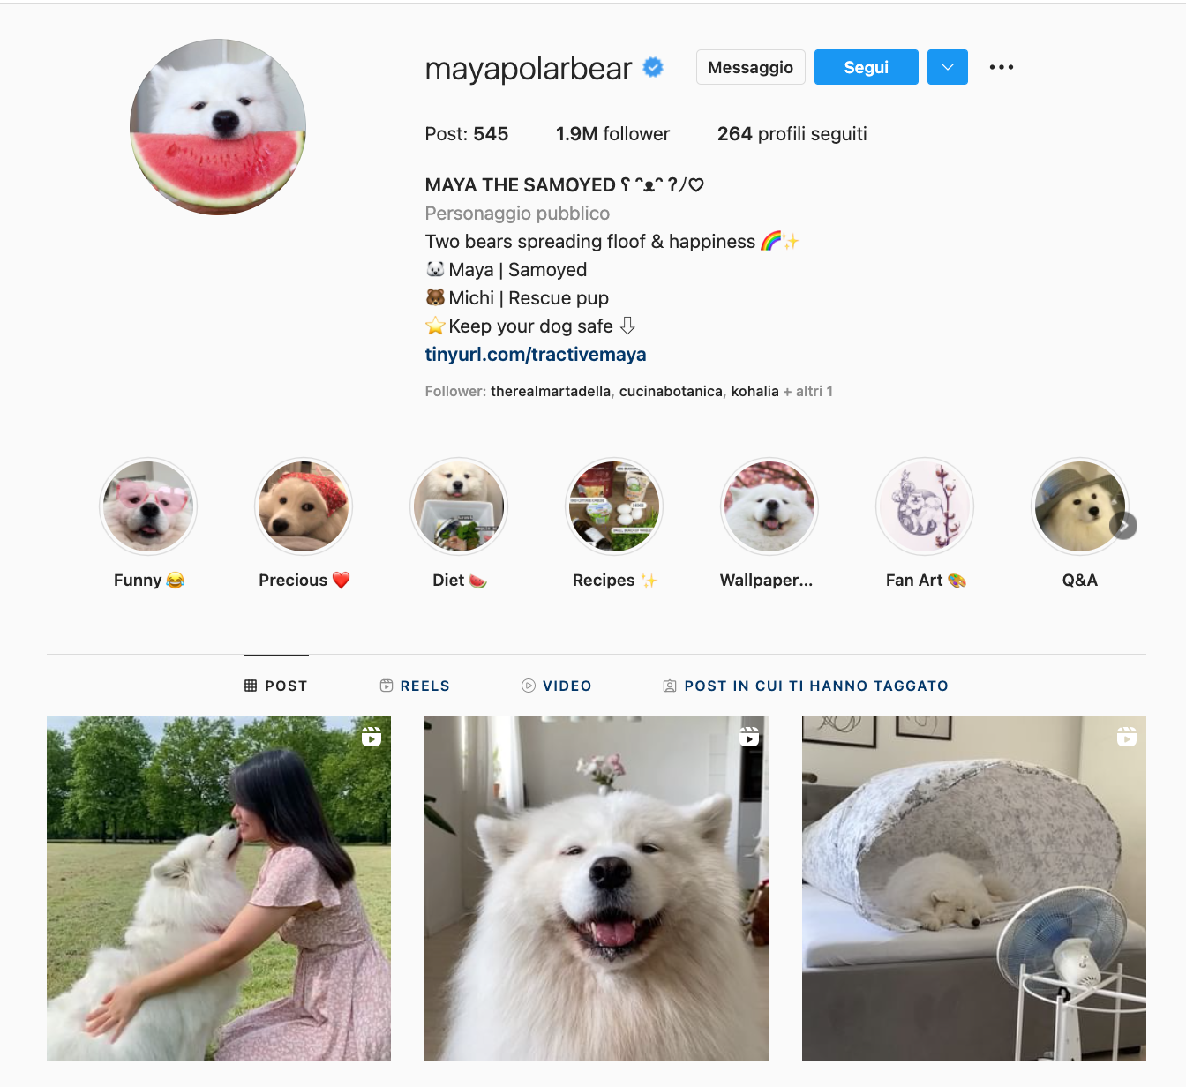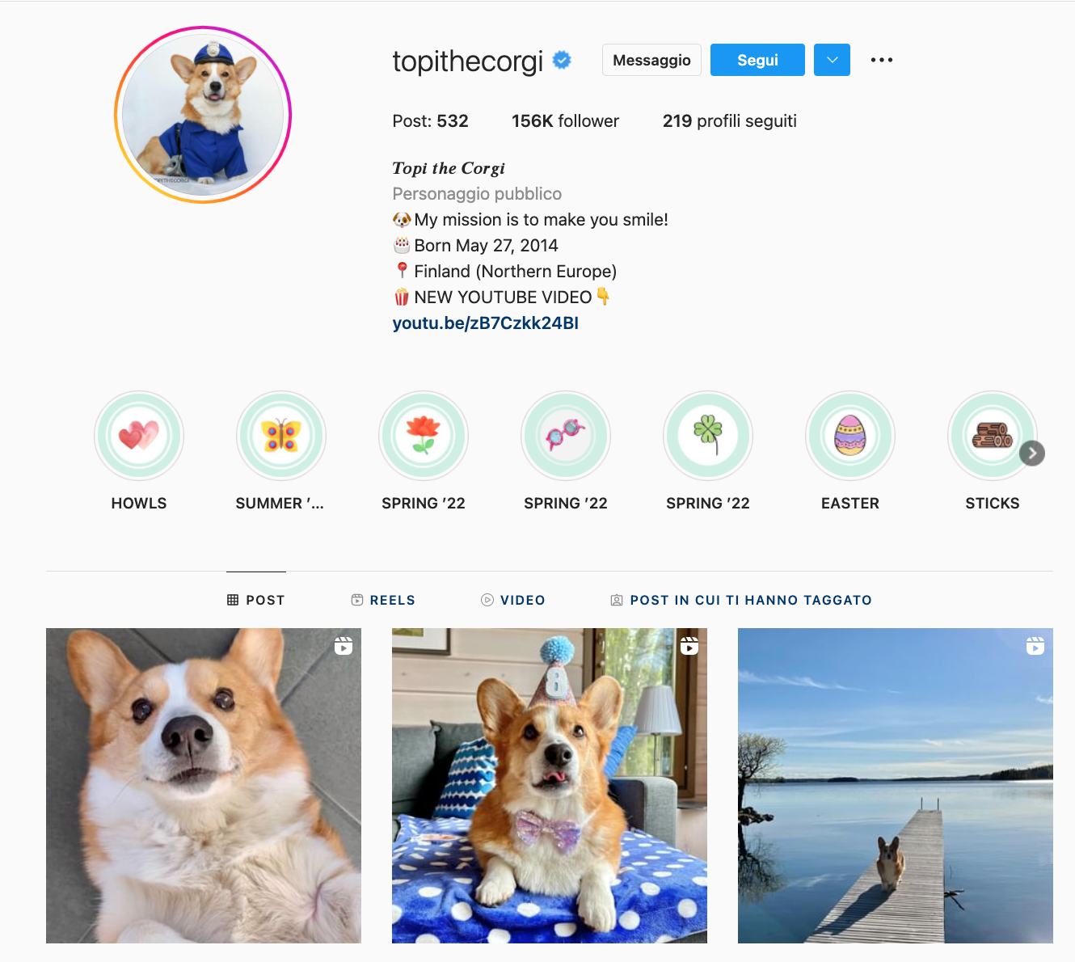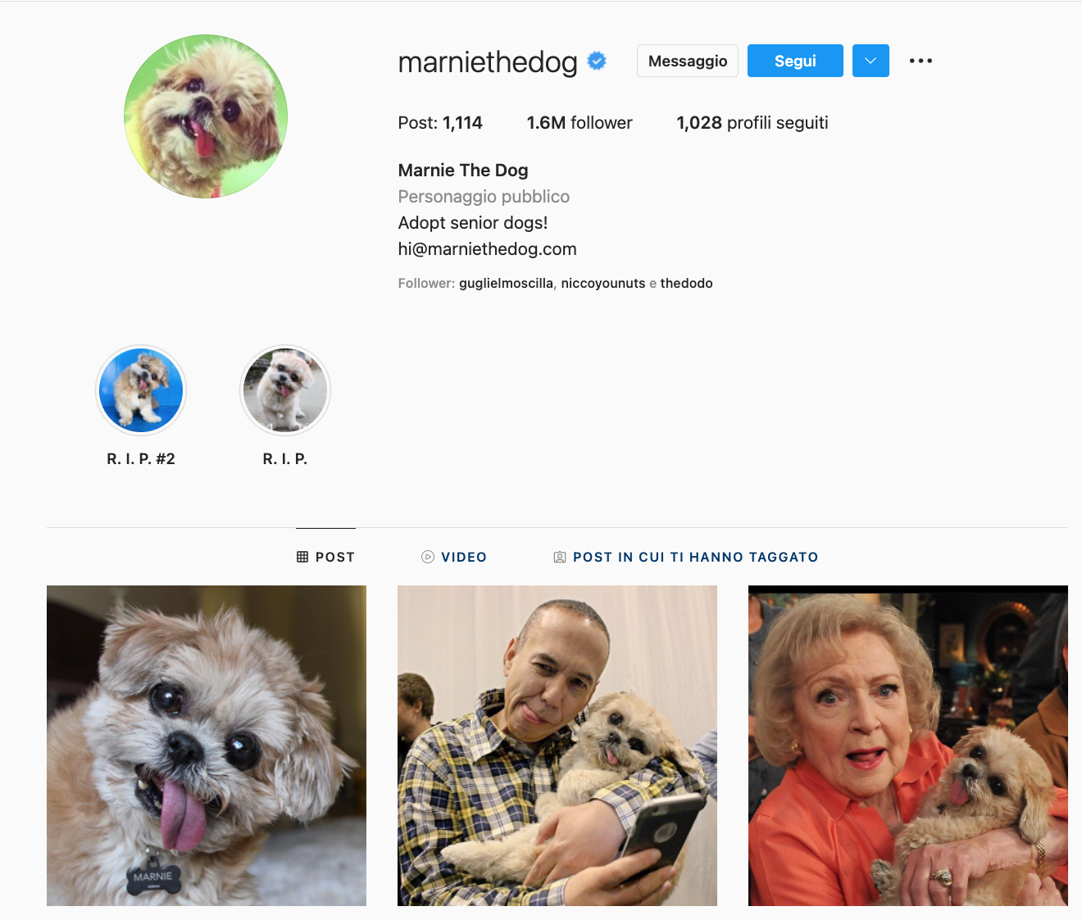

### Chosen cognitive focus among: 1.Attention-Distraction, 2.Language-Narrative, 3. Meaningfulness-Emotions-Empathy, 4. Authenticity perception, 5. Memory-Recall - 2nd step

We then could count on solid basis to go further with the idea of using the sentimental bond between a pet and its human to create a cultural initiative and a related interactive application based on the cognitive focuses of:

3. Meaningfulness-Emotions-Empathy, and

5. Memory-Recall

### 

### Design cards

The (.....) designed by (.....) are a tool that we found very interesting and useful to fix our project in a more museological approach;

We then keep in the track of ideation

their use helped us to frame all the ideas in a certain standard and to define all the practical aspects of the work that had to be done. In this phase of ideation, we decided to continue to analyse and develop both the scenarios: that about a virtual initiative located in a real museum, and that about a virtual museum located exclusively online.

#### STAGE 2 – Define Institutional goal and relevant goals

The goals for both the institutions were quite similar (5/8) even if with different ranking: the to improve the educational contents and favorise the fruition through the user-own-device.

|  |  |
| --- | --- |
| Physical Museum | VE |
| 1. Increase visitor participation 2. Attract new demographics 3. **Increase online visits\*** | 1. Increase international reach 2. **Increase online visits\*** 3. Change visitor attitudes and beliefs* |

|  |  |
| --- | --- |
| Physical Museum | VE |
| * Change visitor attitudes and beliefs* * Use assets in new ways* * Increase repeat visits * Increase visitor feedback * Increase outreach* * Increase visitor spend | * Further social media reach * Attract new demographics* * Use assets in new ways* * Increase educational activities * Increase outreach* |

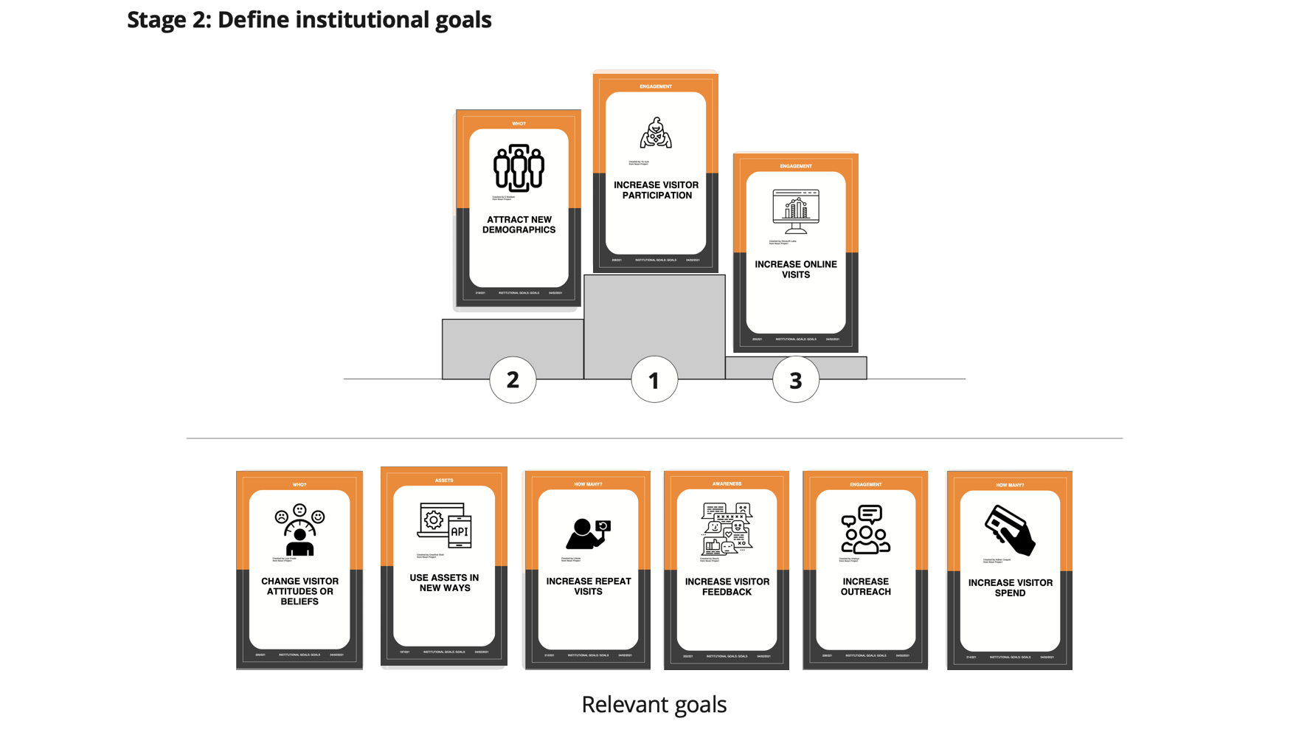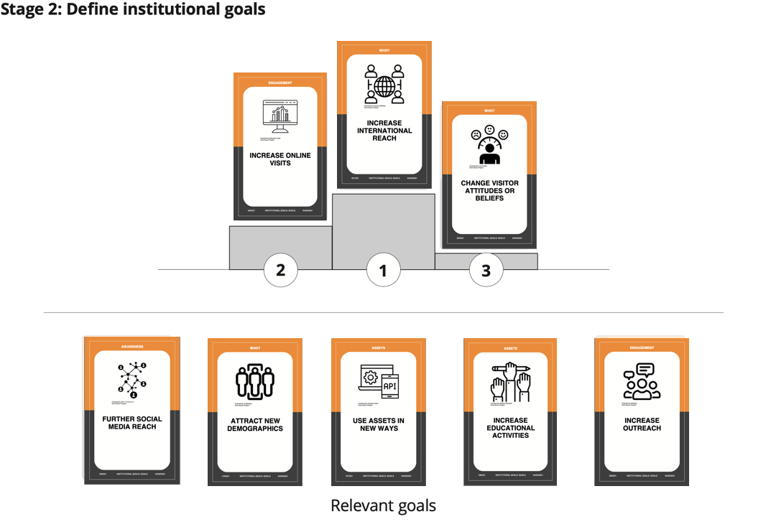

#### STAGE 3 – Create design brief

In the case of the physical museum, the app we thought about was an mobile-interaction based app through which the visitor could have higher interaction with the exhibit using its own smartphone or tablet.

In the case of the virtual museum the idea was different, but similar under some aspects: to develope

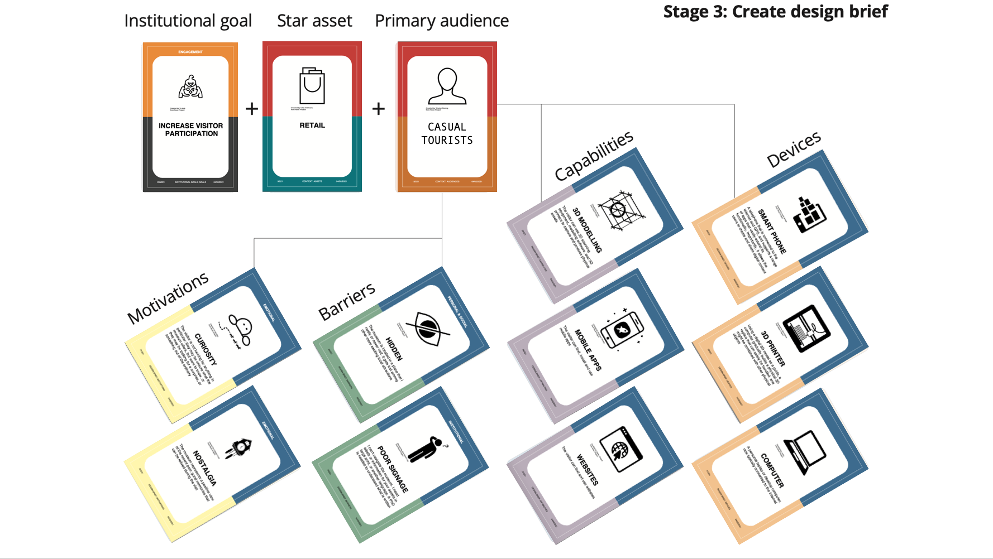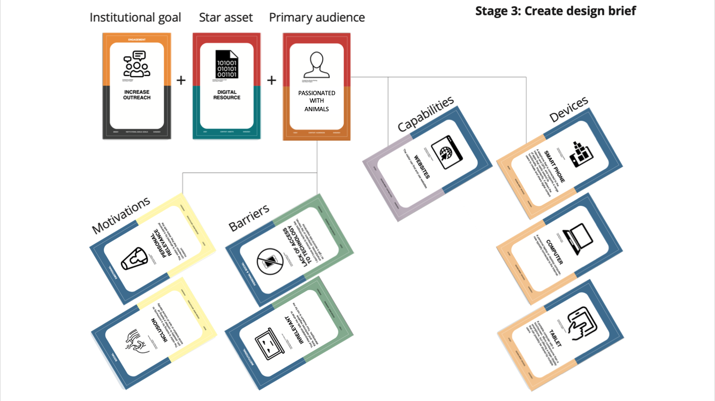

#### FINAL DESIGN

### Creation of the VE

be suitable for both an educational and affective final goal. . The challenge was to not result trivial and at the same time to find a theme that

the question at this point was how to translate it in an interesting idea for a cultural initiative. The challenge was to not result trivial and at the same time to find a theme that could be suitable for both an educational and affective final goal.

To help our analysis, we used two useful tools: a preliminary tab with pros and cons, and the design cards.

#### FIRST ATTEMPT: Animals in art

At first, we decided to investigate the presence of animals in art: how it is considered, and which are the most famous works that show animals as protagonists.

At the end of our analysis, we concluded that the topic was weak on many aspects: the triviality of the argument could make the initiative **less attractive** or addressed to a little category; also, the project would have a more didactical finalization.

On the other side, it would be **easy to retrieve** material about the topic, or to expose it in a physical exhibit; but this idea wouldn't suggest innovation or stimulation on the audience, and on a **more emotional** level it wouldn't leave nothing to the visitor.

**PROS-CONS TABLE**

**attractiveness CONS**

**documentation PROS**

**feasibility PROS**

**emotionality CONS**

#### SECOND (FINAL) ATTEMPT: Artist’s pet Stories

intro

The second topic seemed more suitable to our purposes because it involves the emotional sphere of the visitor empathizing with the artist’s affective world.

It focused more on the emotional aspect than on the artistic one and, for this reason, the recruitment of the material could be more difficult.

**PROS-CONS TABLE**

**attractiveness PROS**

**documentation CONS**

**feasibility PROS**

**emotionality CONS**

### Conceptual map

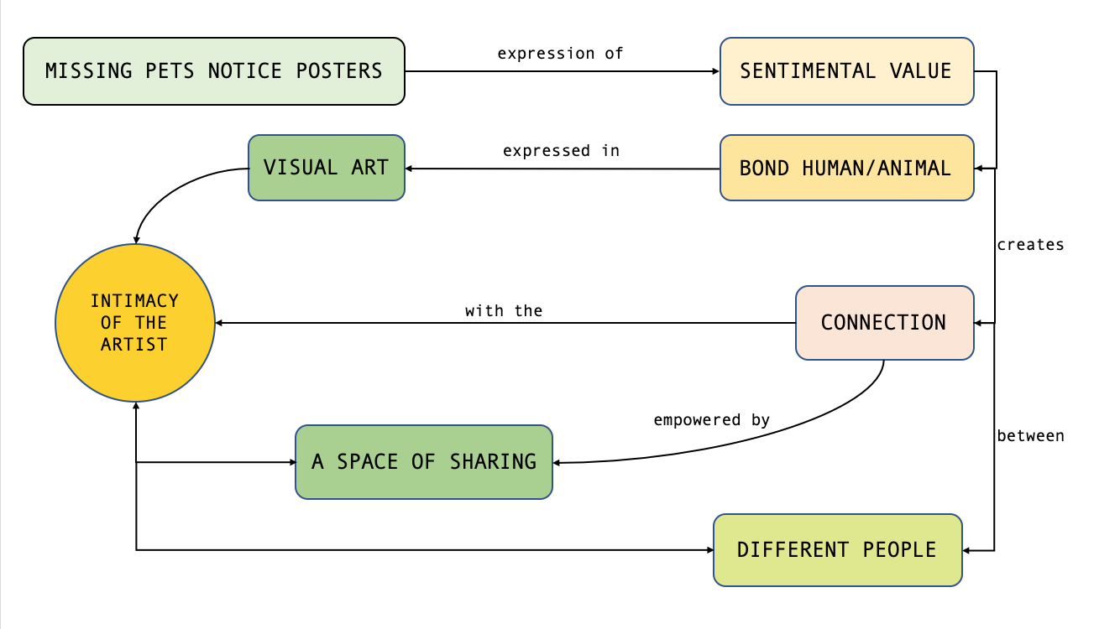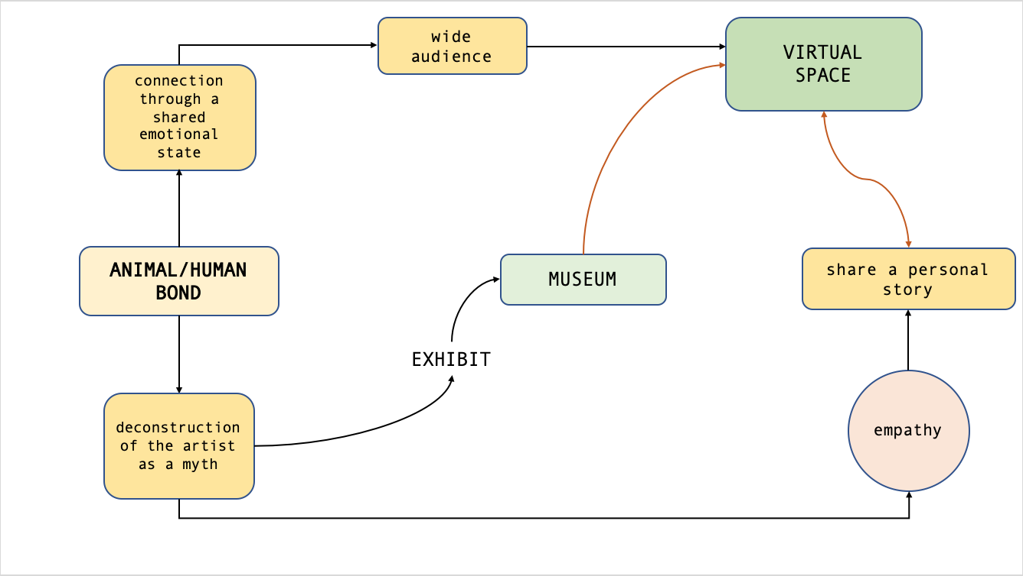

[conceptual](https://enri-ca.github.io/WANTED/conceptual.html)

### B. The museological approach - 3rd step

We then started to think about the topic in a museological view trying to find the best way to translate it into a cultural journey.

Since the theme belongs to an emotional conceptuality, a good idea could be to express it through a story that accompanies the user as in a journey, articulated in simple steps repeated for every artist considered as:

1. A brief introduction on the pet artist story
2. More info about the artist
3. More info about the pet
4. The Artist’ room: showing some of their work related to the human-pet bound and the work of art portraying the pet
5. Further suggestions to know more about the topic

We then created a “classic” virtual exhibition based on Omeka.net, a tool that allowed us to create a database of work of art, collections, and exhibition path, as well as to propose to the user advanced tools for search and browse through the items proposed.

To this scope, we completed the museological path for two pilot artists – Frida Kahlo and Giosetta Fioroni – while we limited just to list other possible artist-pet relationship to be explored – elenco.

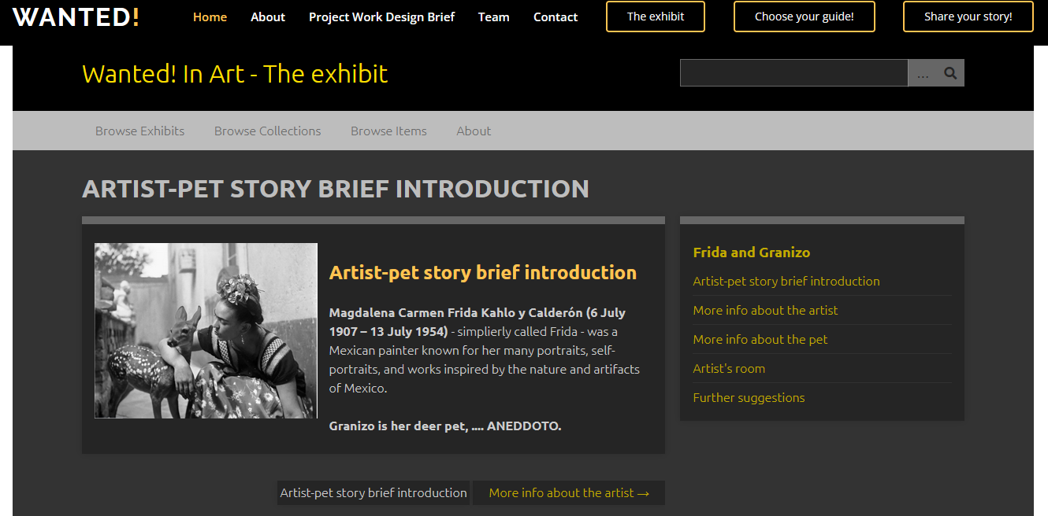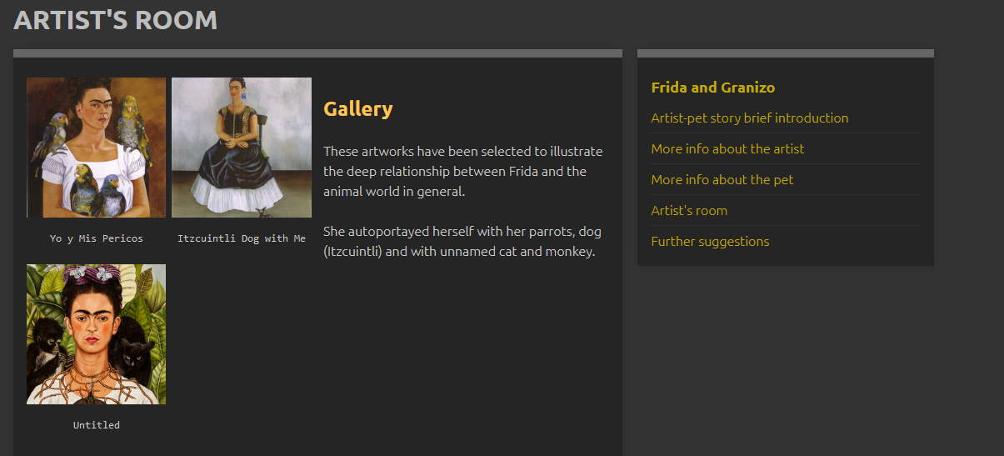

We also devised a more interactive application “Choose your guide” that give the possibility to explore a 3d exhibition with a freer path but with the help of a proper guide, instead of being autonomous in reading the critical parts and linearly scroll the contents; the guide will also suggest further activities at the end of the visit to engage more the user.

The 3d visit is then divided in rooms, accordingly with the path of the Virtual linear exhibition, each of which is dedicated to a different artist and its bond with their pet and other animals. The virtual room is showed as a real museum room (walls, sofa, paints with panels), the paintings have an interactive panel trough which (by clicking it) the user can visualize the work and go into detail.

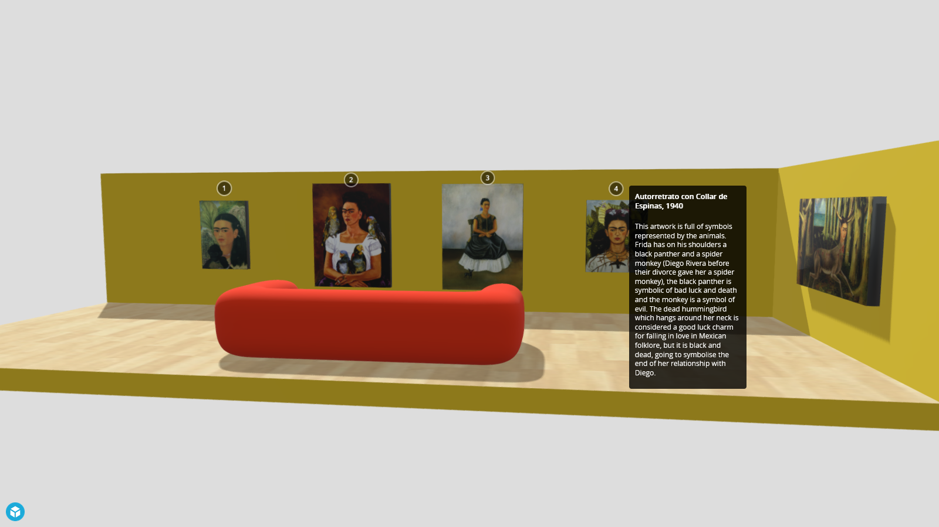

The information section showed by the panel is divided in some parts; a brief history of the artist, why we choosed him/her for our project and the analysis of most of the emblematic works that can be useful for the user to understand the importance of the animal in the creative processes of the artist.

we choose to insert inside the space are the most representative of a connection with an animal; each paint

The VE and the related applications, whose details will be discussed in the Development section, having engagement and education as primary goals, can be classified in the E or F category, according to Simona Caraceni taxonomy:

|  |  |
| --- | --- |
| NEED | Interpretaton - Experimentation/complex museum identity |
| INTERACTION | Open |
| SPACE | Open |
| CONTENT | Selected works - Photograph, books, paintings, geo--- |
| VIRTUAL/REAL | Virtual with real/Virtual with virtual |
| VISITORS CONTRIBUTIONS | Allowed |

E) Virtual museum that enhance museum objects INTERPRETATION with OPEN INTERACTION in an OPEN SPACE showing SELECTED (or ALL OBJECTS) of the museum collection, ALLOWING visitor CONTRIBUTIONS.   
F) Virtual museum making EXPERIMENTS with NEW MUSEOLOGICAL MODELs with OPEN INTERACTION in an OPEN SPACE showing SELECTED (or ALL OBJECTS) of the museum collection, ALLOWING visitor CONTRIBUTIONS.

at the end of which the user is free to express his personal story.

The steps that the user encounter during the journey were chosen on the base of the educational and sentimental goal that this project want to reach.

### QUI VA AGGIUNTO UN PICCOLO RIASSUNTO SU: TARGET, SPACE, GOALS, APPROACH

### (c) experience design (from the users perspective) (include a diagram)???

## Goals (cultural, cognitive, economic, educational, etc.)

As we have seen in the development of the institutional goals, the virtual exhibition and the related applications cover several goals in different areas.

In particular,

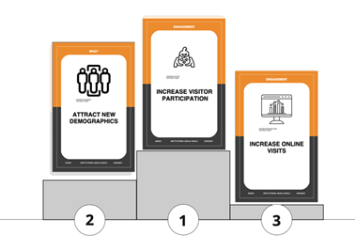

Economic: increase online visits and connected merchandising (3d print your pet, Wanted! traiding cards and album, Guess Who Wanted! ed., etc.)

Cultural and educational: attract new demographics

Cognitive: increase visitor participation (new services as “Search for your pet”)

## Requirements

A requirement is something that your product should do or a quality it should have listed in accordance with its importance:

* MUST: involve the user, give educational content
* SHOULD: promote the museum
* COULD: improve
* WILL NOT: be as exhausting as the classical virtual exhibition, thought for a different public with more didactical infos and less interaction

They are defined from data on context, content, and people (and their needs).

# Development

## (a) The story (include an interactive narrative using Twine)

Our story tells about a young-adult visitor looking for a new approach art history exhibition. He or she finds the Wanted! website where it is possible to access a short historical preview in the In History section and a selection of pieces of art in the In Art section. She or he is emotionally involved due to their childhood and recent souvenirs about their pets. They enjoy the exhibition, they gain more knowledge and they are happy to contribute at Your stories section with their pets' stories. Moreover, they are happy and amused to realize a 3d rendering of their pet to be used in VR or AR and to be able to order for a 3d printed model of it to be gifted.

### PERSONAE

|  |  |
| --- | --- |
|  |  |

### SCENARIOS

|  |  |
| --- | --- |
|  |  |

## (b) Description of the interaction between the project and the users (include Interaction Diagram)

### Choose your guide

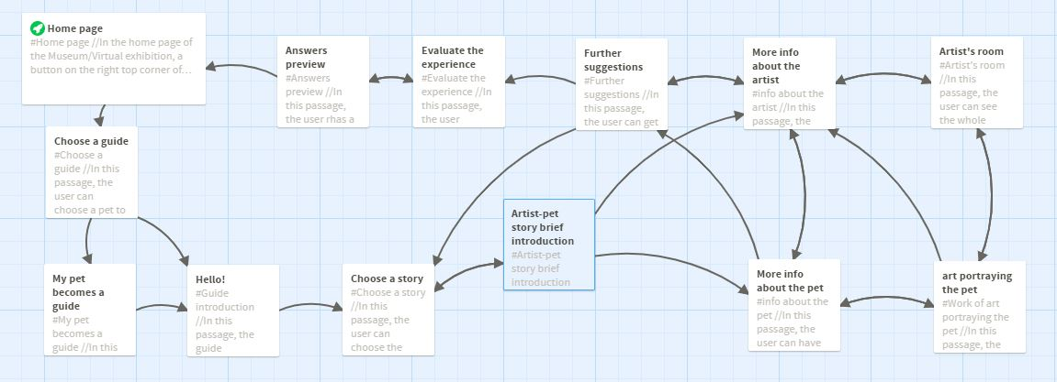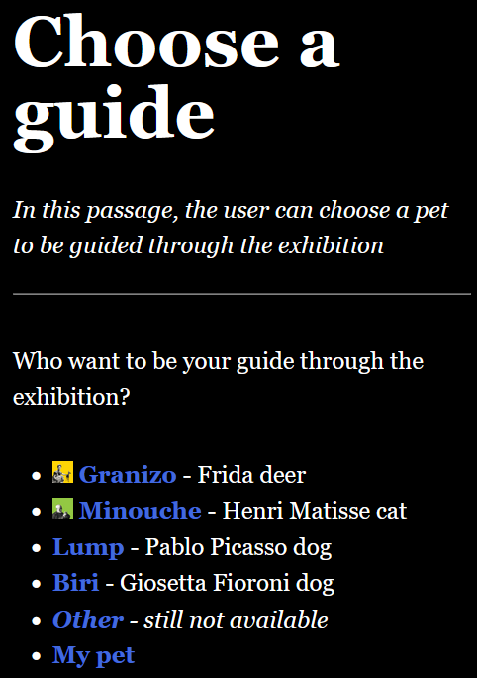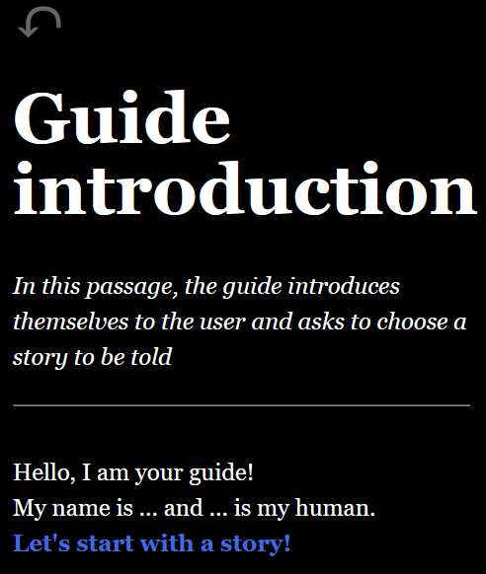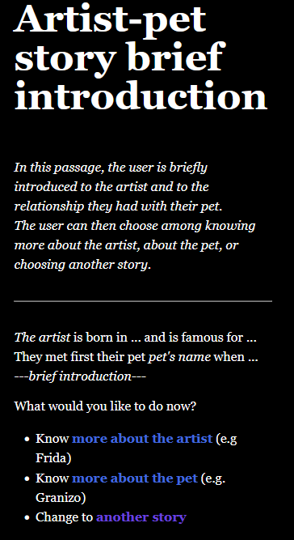

### Share your Stories

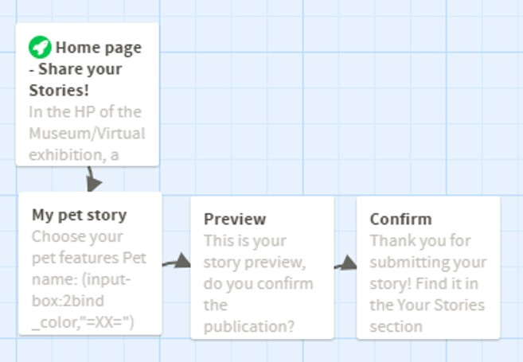

### 3d print your pet!

### Search for your pet!



## (c) Development to reach the cognitive focus

## (c) Foreseen workflow (includes needed software, hardware, professionals)

The actual realization of the sketched Virtual Exhibition and the related applications surely required a **multidisciplinary team** with professionals covering all aspects of issues related to contents or technical aspects; here just a probability incomplete list:

1. Art historian: to curate the scientific aspects of the exhibition and the related documentation
2. Art curator/gallerist/copyright lawyer: to face the copyright issues and possible request of reproduction
3. Pedagogist: to balance the contents and the language used according to the different target of the classical VE or the interactive app
4. a software developer – if not adopted a friendly software - in charge of the back-end;
5. Communication team and Social media manager: to curate the website and the social media and reach new public and realise marketing strategies
6. User experience expert and a 3d modeller: to realize 3d guides and 3d artists’ rooms
7. Someone with expertise in evaluating the impact and the feedback

For the realization of the pilot version of VE and the related applications, we used the following software and tools:

1. Github
2. Omeka.net
3. Blender
4. Twine
5. Zephir 3d

## (d) Further development and maintenance issues

s we have already mentioned, the MAC is looking forward to expanding its exhibition both by including remains currently stored in its deposit and by acquiring new holdings from the Hellenistic and Byzantine sites. The MAC App could thus be enriched with new contents and materials by creating new thematic paths and interactive stories.

# Team roles

|  |  |
| --- | --- |
| Enrica Zani and Bigio | Alisia Zarbo |
|  |  |
| Basic idea and preliminary data section; physical museum analysis; Virtual Exhibition building with Omeka.net; application interaction diagram with Twine; merchandising ideation; privacy and copyright issues; bibliography | Ideation card; museological approach; social media analysis; Personae; Scenarios with Twine; Virtual Frida's room with Blender; feasibility plan. |

# Bibliography

## Project

* Caraceni taxonomy
* Caraceni Mewseografy
* Quelli della classificazione museale
* Haraway. *The Companion Species Manifesto: Dogs, People, and Significant Otherness*, 2003

## In History section (vedere se riusciamo a richiamare le bibliografie dei modals)

* Arluke, Arnold., and Lauren. Rolfe. *The Photographed Cat Picturing Human-Feline Ties 1890-1940*. First ed. 2013.
* *Dogs & Cats in Art Wednesday, 22nd January 1997*. London: Bonhams, 1996. https://almastart.unibo.it/permalink/f/10694hg/39UBO_SEBINA_DSUBO3965883

## In Art section

* Barbara Amadasi. "Animal Farm." *Vogue (Italia)*, no. 716 (2010): 74. https://almastart.unibo.it/permalink/f/pt4j7f/TN_cdi_proquest_miscellaneous_1847846888
* Fioroni, Giosetta. *Dog*. Corraini, 2010.
* https://www.albludiprussia.com/giosetta-fioroni-e-linvenzione-della-famiglia/
* Boltanski, Christian, Fabio Malossi, Beppe Sebaste, Bologna, and Museo per La Memoria Di Ustica Bologna. [*Lista Degli Oggetti Personali Appartenuti Ai Passeggeri Del Volo IH 870*](https://almastart.unibo.it/permalink/f/10694hg/39UBO_SEBINA_DSUBO2411850). S.l: S.n, 2007.

# Complementary Material for the Discussion

## 3d object or scene (3D): Frida room’s

## Trailer (video)--> NO

## Audio (i.e. interviews of your potential users) --> NO

**CHE DICI SE VEDIAMO SE POSSIAMO FAR FARE UN MODELLINO 3D DEL PER PERDUTO CHE UNO SI REALIZZA E SI PORTA A CASA TIPO STATUINA DEL PRESEPE??**